Spark Environment Variable Setup

# Spark on Mac / Linux

sudo vi ~/.bash_profile

This will enter the vim window. Then you need to type ‘i’ for ‘insert’, then paste below 4 lines at the top.

export SPARK_HOME="/Users/user/spark"

export PATH=$SPARK_HOME/bin:$PATH

export PYSPARK_DRIVER_PYTHON=jupyter

export PYSPARK_DRIVER_PYTHON_OPTS='notebook'

Finally, press ESC, type :wq (it means save and quit)

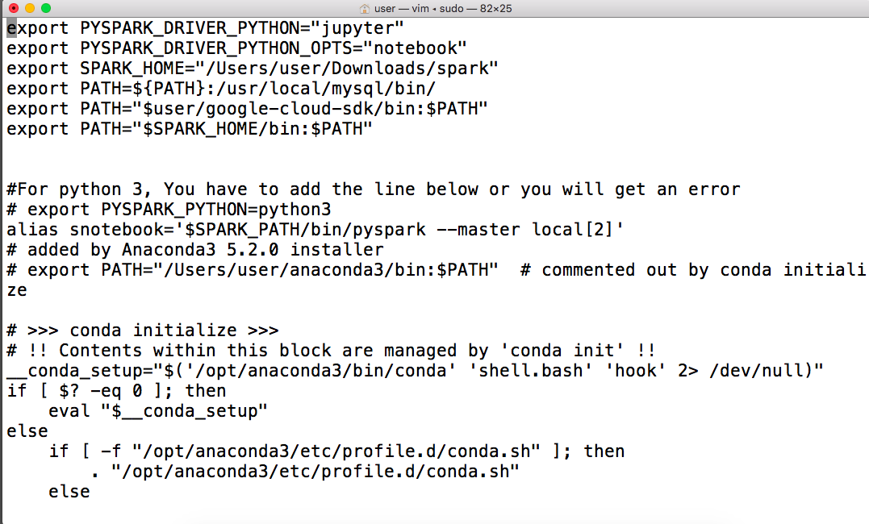

You can then check with ‘printenv’

# Spark on Windows

1. Start -> Edit the System environment variables / Edit the environment variables for your account
2. Click the Environment Variables... button
3. Click New and enter SPARK_HOME as the Variable name and the path to your spark folder as the Variable value then click OK
4. Click New and enter PYSPARK_DRIVER_PYTHON as the Variable name and jupyter as the Variable value then click OK
5. Click New and enter PYSPARK_DRIVER_PYTHON_OPTS as the Variable name and notebook as the Variable value then click OK

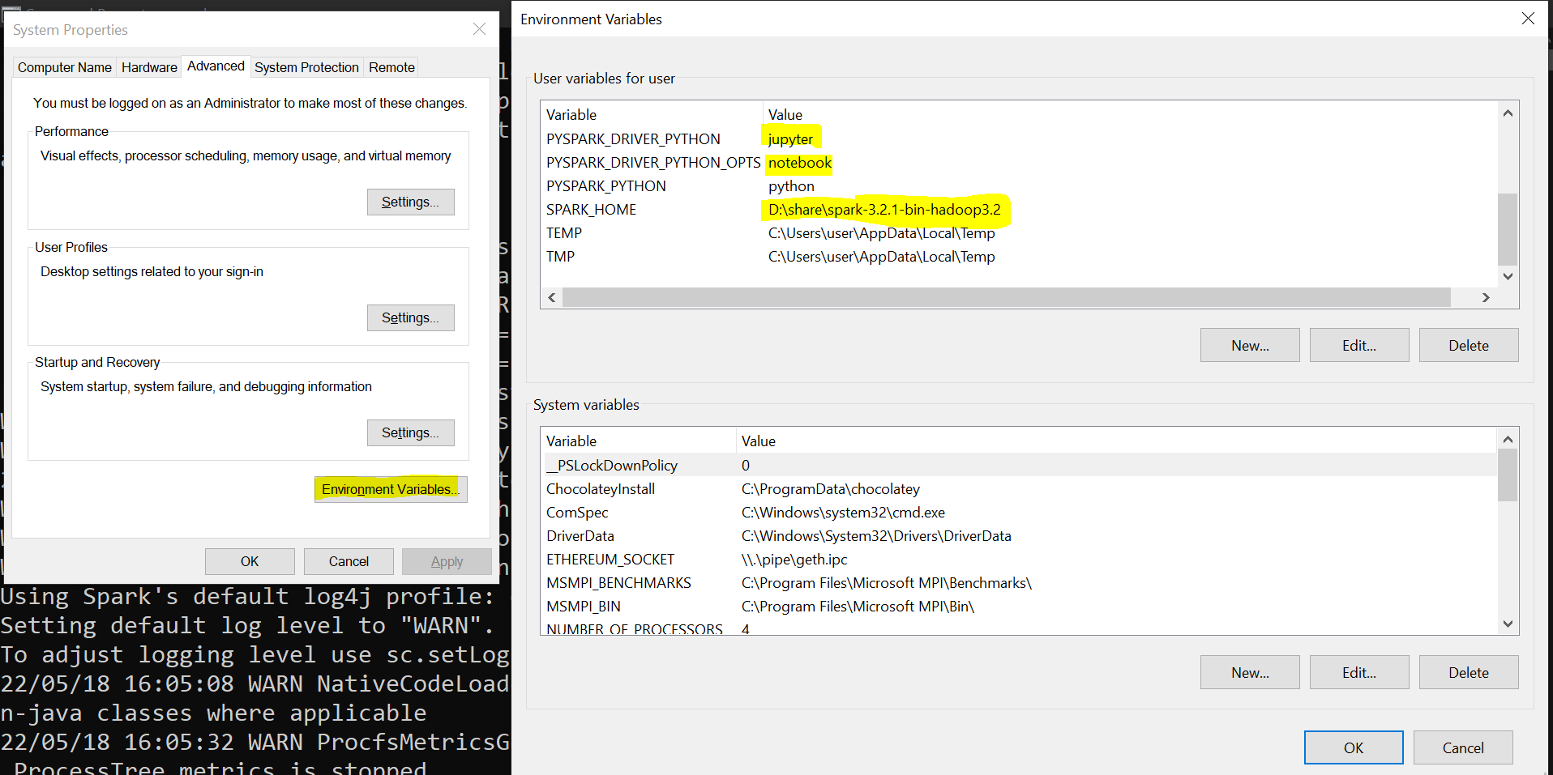

1. Select the Path variable and click Edit...
2. Click New and type out the path to the %SPARK_HOME%\bin folder then click OK

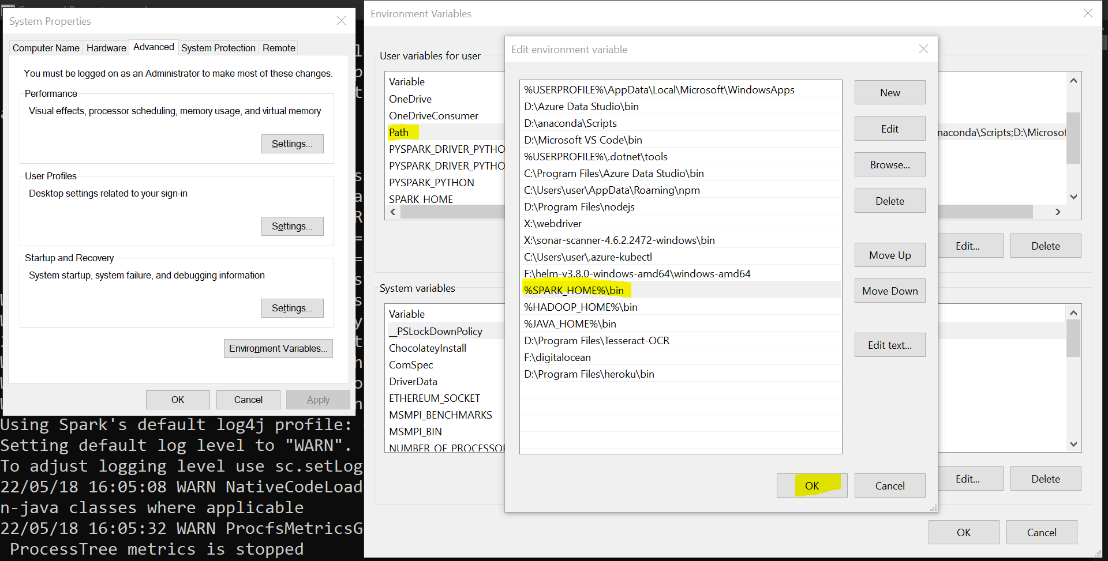

1. Click OK on the Environment Variables window
2. Click OK on the System Properties window
3. Note: If the above steps don’t work, then we may also need to check if Java is installed and configured properly.

